Date:
06/22/2014 - 12:00am to 06/24/2014 - 5:00pm
Location: RIT Blg 78- Room 2230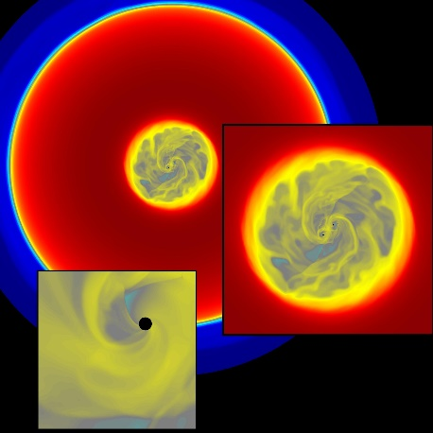
Participants: Manuela Campanelli (RIT), Joshua Faber (RI), Scott Noble (RIT), Dennis Bowen (RIT), Yosef Zlochower (RIT), Brennan Ireland (RIT), Eric West (RIT), Zach Silbelman (RIT), Davide Lena (RIT), Julian Krolik (JHU), Jeremy Schnittman (NASA GSFC), John Baker (NASA GSFC), Bernard Kelly (NASA GSFC), Cole Miller (UMD via Skype), Zach Etienne (UWV via Skype), Ian Ruchlin (RIT), James Healy (RIT), Carlos Lousto (RIT), Bruno Mumdim (AEI, Germany), Hiroyuki Nakano (Kyoto, Japan), Miguel Zilhao (RIT).

Schedule:
Schedule Day 1 (June 23),
9:30 Breakfast
10:00 - 10:15 Manuela Campanelli - Opening Remarks and Logistics
10:15 - 11:15 Julian Krolik - Prograde Circumbinary Disk Leakage Fraction, and follow-up discussion [PDF]
10:15 - 12:35 Jeremy Schnittman - Orbital Evolution in the presence of retrograde circumbinary disk, and follow-up discussion [PDF]
12:35 - 13:45 Lunch at Cross Roads
13:45 - 14:45 Joshua Faber - Full GRMHD Codes Suites
14:45 - 15:45 Bernard Kelly/ John Baker - NASA GSFC Progress Report
15:45 - 16:00 Break
16:00 - 17:30 Approach to merger and relaxation postmerger, and follow-up Discussion

Schedule Day 2 (June 24),
09:30 Breakfast
10:00 - 11:30 Scott Noble - MHD dynamics of Inspiralling BBH with the black holes on the grid, and follow-up discussion
11:30 - 12:00 Miguel Zihlao - Spacetime Dynamics and Warped Coordinates, and follow-up discussion
12:00 - 13:30 Lunch Break at Cross Roads
13:30 - 14:30 Hiroyuki Nakano - Spinning Black Hole Binaries Spacetime Construction
14:30 - 15:00 Bruno Mundim - PostMerger, and follow-up discussion
15:00 - 16:00 Dennis Bowen - Hydrodynamics Studies of Accretion Disks in BBH Spacetime
16:00 - 16.30 Zach Etienne - Illinois GRHMHD: Status Report
16:30 - 17:30 Manuela Campanelli - Future Relativistic Projects, Follow-up Discussion

