Date:
08/23/2010 - 10:00am to 08/26/2010 - 6:00pm
CCRG hosted the Carpet Developer workshop on August 23-27, 2010, in the RIT's Student Innovation Center (room 1100).
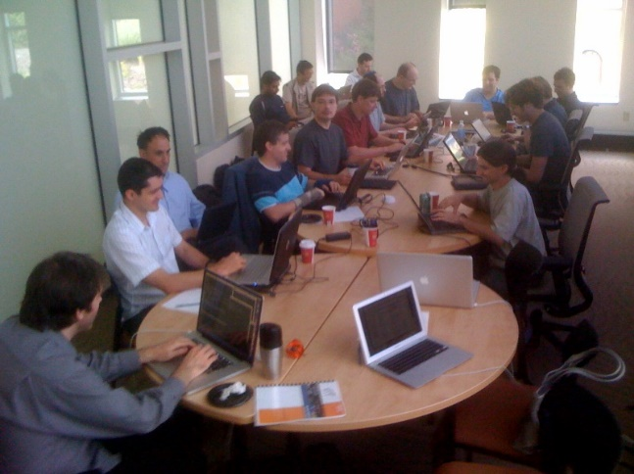
Carpet and Cactus code developers met with users and high-performance-computing (HPC) specialists to discuss and implement new adaptive-mesh-refinement (AMR) algorithms, aimed at improving the performance of numerical relativity codes for astrophysics applications in current and future high-end petascale architectures, such as the NCSA's Blue Waters.
The workshop was co-organized by Bruno Mundim (RIT), Manuela Campanelli (RIT) and Erick Schnetter (LSU) and was co-sponsored by the RIT's Center for Computational Relativity and Gravitation and by two NSF PRAC awards OCI-0941653, OCI-0832606.
Details about this workshop can be found in the wiki website.

